**NAME: Meet Anand Raut**

**DIV: S2-1**

**ROLL NO: 2201084**

* **EXPERIMENT – 12:**

* ***AIM:*** **To study and implement program on demonstrating CRUD (create, red, update and delete) operations on database (SQLite/MySQL) using python**

* ***THEORY:***

# **Python SQLite – CRUD Operations:**

## **CRUD Operations:** The abbreviation CRUD expands to Create, Read, Update and Delete. These four are fundamental operations in a database. In the sample database, we will create it, and do some operations. Let’s discuss these operations one by one with the help of examples.

#### **CREATE**

The create command is used to create the table in database.



#### **INSERT**

This refers to the insertion of new data into the table. Data is inserted in the form of a tuple. The number of attributes in the tuple must be equal to that defined in the relation schema while creating the table.

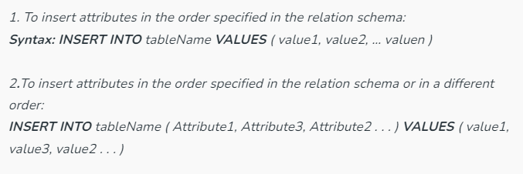

**READ**

This refers to reading data from a database. A read statement has three clauses:

1. **SELECT:**Takes as the predicate the attributes to be queried, use **\***for all attributes.
2. **FROM:**Takes as the predicate a relation.
3. **WHERE:**Takes as the predicate a condition, this is not compulsory.

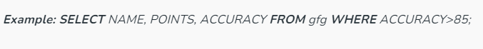

### UPDATE

This refers to the updating of tuple values already present in the table.

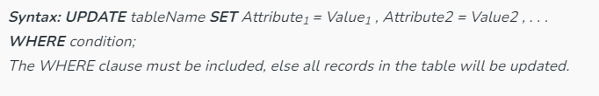

### DELETE

This refers to the deletion of the tuple present in the table.

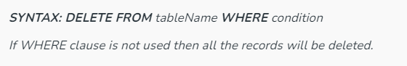

* **PROGRAM:**

import sqlite3

from tkinter import *

# Create an SQLite database connection

conn = sqlite3.connect('registration.db')

cursor = conn.cursor()

# Create the users table if it doesn't exist

cursor.execute('''

CREATE TABLE IF NOT EXISTS users (

id INTEGER PRIMARY KEY,

name TEXT,

email TEXT,

contact_number TEXT,

gender TEXT,

country TEXT,

password TEXT

)

''')

def register_user():

# Get form input values

name = en1.get()

email = en2.get()

contact_number = en3.get()

gender = var.get() # Assumes var is an IntVar from radio buttons

country = var_country.get() # Assumes var_country is a StringVar from the dropdown

password = en6.get()

# Insert user data into the database

cursor.execute('''

INSERT INTO users (name, email, contact_number, gender, country, password)

VALUES (?, ?, ?, ?, ?, ?)

''', (name, email, contact_number, gender, country, password))

conn.commit()

clear_entries()

def clear_entries():

en1.delete(0, 'end')

en2.delete(0, 'end')

en3.delete(0, 'end')

en6.delete(0, 'end')

var.set(0)

var_country.set("Select Country")

def view_data():

view_window = Toplevel()

view_window.title("View Registered Data")

view_window.geometry("600x300") # Adjust window size here

scrollbar = Scrollbar(view_window)

scrollbar.pack(side=RIGHT, fill=Y)

listbox = Listbox(view_window, yscrollcommand=scrollbar.set, width=80) # Adjust width here

listbox.pack(side=LEFT, fill=BOTH)

scrollbar.config(command=listbox.yview)

cursor.execute("SELECT * FROM users")

data = cursor.fetchall()

for row in data:

listbox.insert(END, row)

def delete_data():

delete_window = Toplevel()

delete_window.title("Delete Data")

Label(delete_window, text="Enter Name to Delete:", width=20, font=("arial", 12)).pack()

entry_name = Entry(delete_window)

entry_name.pack()

def delete():

name = entry_name.get()

cursor.execute("DELETE FROM users WHERE name=?", (name,))

conn.commit()

delete_window.destroy()

Button(delete_window, text="Delete", command=delete).pack()

# Create the registration form

base = Tk()

base.geometry("500x500")

base.title("Registration Form")

Label(base, text="Name:", width=15, font=("arial", 12)).place(x=20, y=120)

en1 = Entry(base)

en1.place(x=200, y=120)

Label(base, text="Email:", width=15, font=("arial", 12)).place(x=20, y=160)

en2 = Entry(base)

en2.place(x=200, y=160)

Label(base, text="Contact Number:", width=15, font=("arial", 12)).place(x=20, y=200)

en3 = Entry(base)

en3.place(x=200, y=200)

Label(base, text="Gender:", width=15, font=("arial", 12)).place(x=20, y=240)

var = IntVar()

Radiobutton(base, text="Male", variable=var, value=1).place(x=200, y=240)

Radiobutton(base, text="Female", variable=var, value=2).place(x=270, y=240)

Label(base, text="Country:", width=15, font=("arial", 12)).place(x=20, y=280)

var_country = StringVar(base)

var_country.set("Select Country")

dropdown = OptionMenu(base, var_country, "INDIA", "Canada", "UK", "Australia")

dropdown.place(x=200, y=280)

Label(base, text="Password:", width=15, font=("arial", 12)).place(x=20, y=320)

en6 = Entry(base, show='*')

en6.place(x=200, y=320)

Button(base, text="Register", width=10, command=register_user).place(x=200, y=400)

Button(base, text="View Data", width=10, command=view_data).place(x=300, y=400)

Button(base, text="Delete Data", width=10, command=delete_data).place(x=400, y=400)

base.mainloop()

# Close the cursor and connection

cursor.close()

conn.close()

* **OUTPUT:**

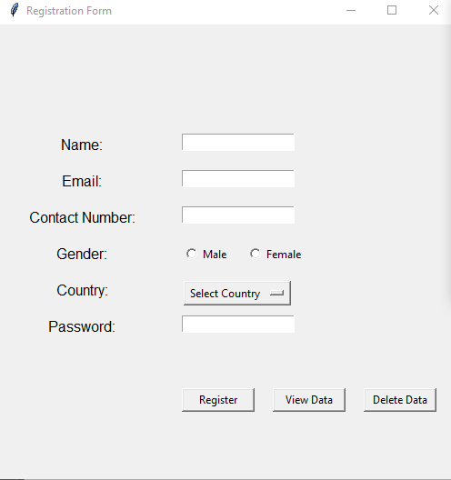

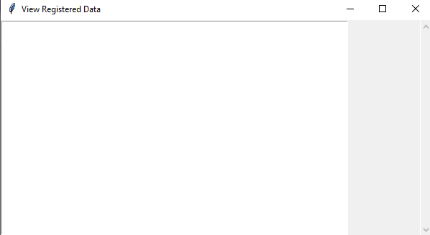

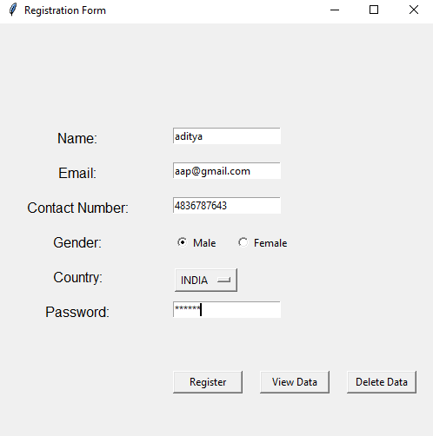

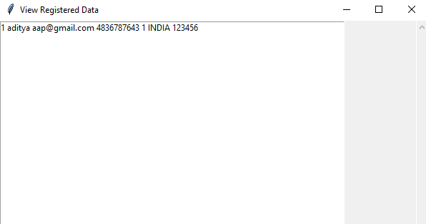

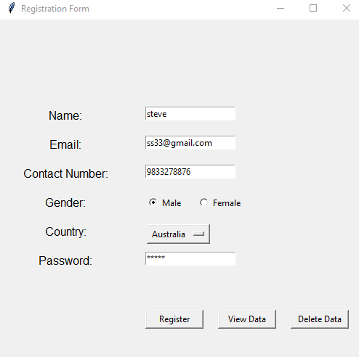

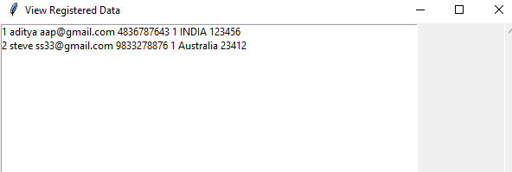

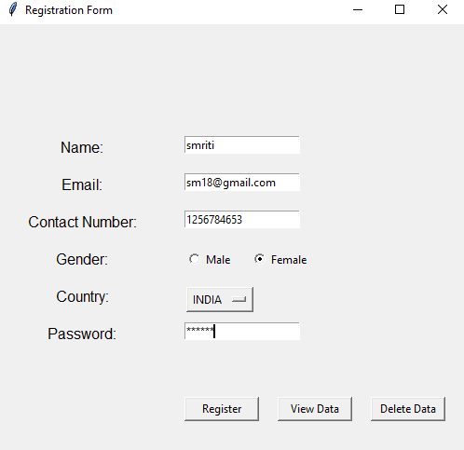

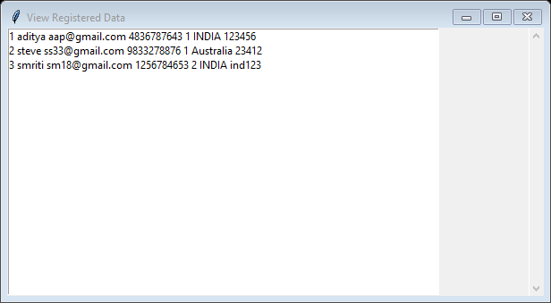

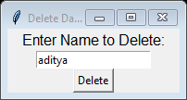

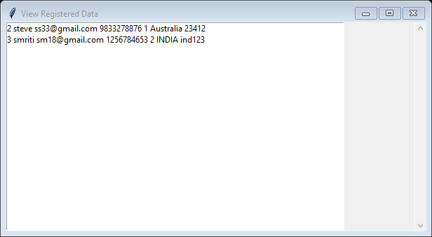

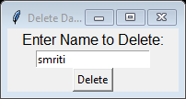

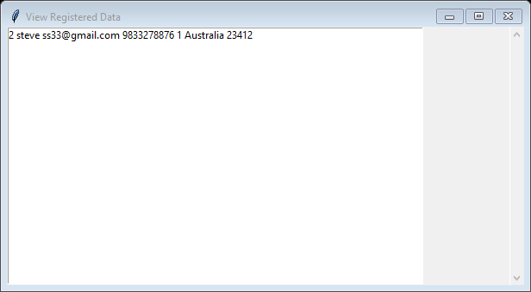

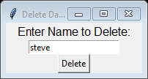

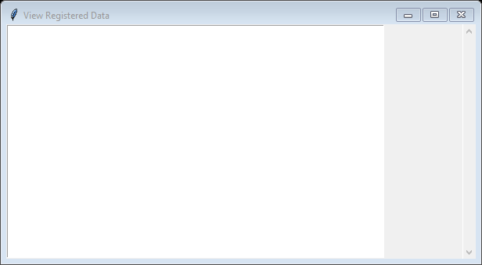

* ***CONCLUSION:*** **Hence, we have successfully implemented program on demonstrating CRUD operations on Registration form using SQLite python; LO 1.**